**25-04-2022**

**ng new project-name**

**cd project-name**

**code . (open the project in vs code)**

**ng serve –o (automatically after 100% compiled it will open in default browser)**

**Angular is known as component base architecture framework.**

**Component always control the view or part of the view on web page.**

**Every component work independently.**

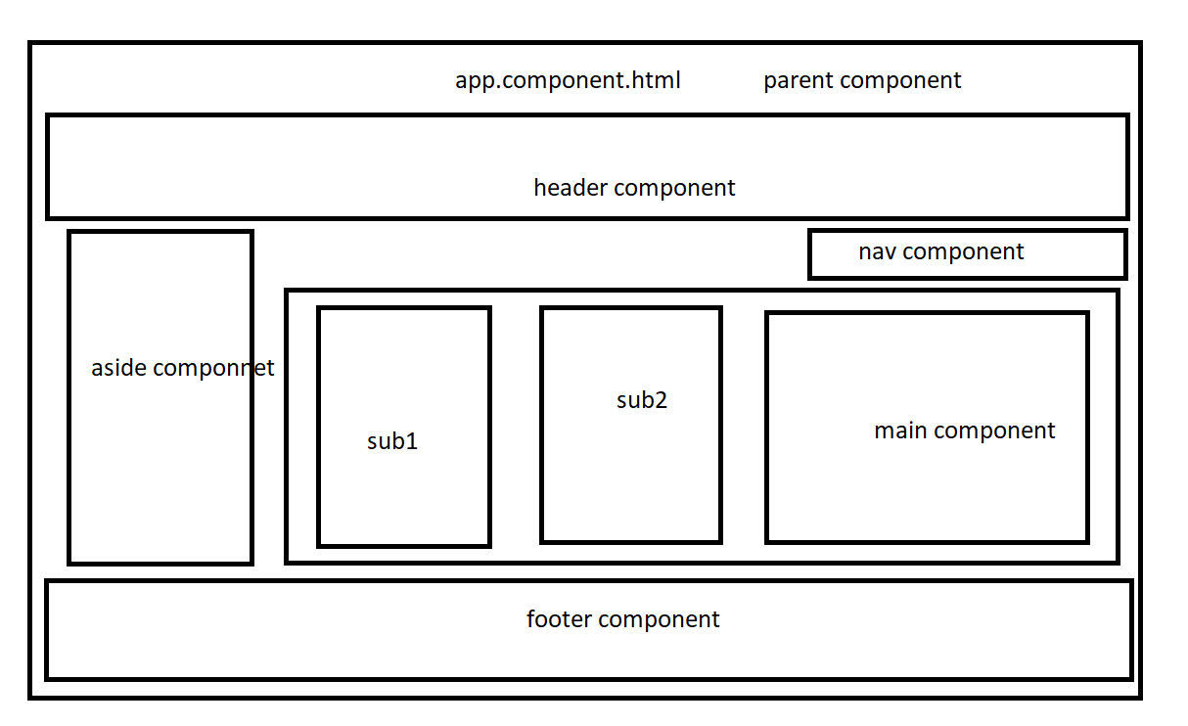

**In Angular using component we are creating user-defined tags.**

**<app-root></app-root>**

**We can create user-defined tag using selector attribute part @Component decorator.**

**app.module.ts**

**module : it is collection of more than one component like a package in java.**

@NgModule: using this decorator we can make normal class as a module.

Attribute

Declaration : in this section we have to provide component details.

Imports : this attribute hold the default about user-defined or pre-defined modules details.

BrowserModule.

Provider : this attribute provide the details about angular service class.

Bootstrap : this component load first as a parent components.

Main.ts

Login module application module customer module

createLogin applicationcreate

updatelogin applicationdelete

deleteLogin applidateupdate

AppModule

AppComponent

**ng new angular-data-binding**